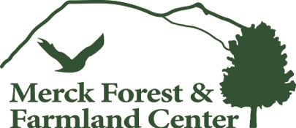
Dear Parent / Guardian,

We are excited to have your child’s group scheduled to come to Merck Forest for an outdoor, hands-on-learning field trip to our farm and forest. We strive to work with your child’s group leader(s) to provide a safe, enjoyable experience. You can do your part to help your child have an enjoyable experience as well by seeing that they are well prepared.

Merck Forest is a backcountry setting. In the event of any emergency situation, we are at least an hour away from definitive care and emergency services. Preparedness in the backcountry is essential. The majority of activities at Merck Forest take place outside, and our higher elevation and wind chill factor can often mean temperatures that are cooler than in the valleys (as much as 15° colder than lower elevations). Dressing appropriately for the conditions is a matter of safety, not just comfort!

Dressing in layers is highly recommended, and having the proper clothing is mandatory. Please look carefully at the checklist attached and make sure that any items not actively worn by your child are packed for them. The graphic at the end of this letter is a useful tool to prepare your child for their time at Merck Forest.

Lunches: Merck Forest is a pack-in, pack-out facility. Your child will be asked to pack all their garbage out and take it home with them. Please consider using reusable containers when packing your child’s lunch. And don’t forget utensils, if they need them!

We work hard to make sure your child has a wonderful time with us as they explore the natural world at Merck Forest. Thank you for helping them to have a great experience.

John Schneble, Education Director Elena Santos, Education Manager

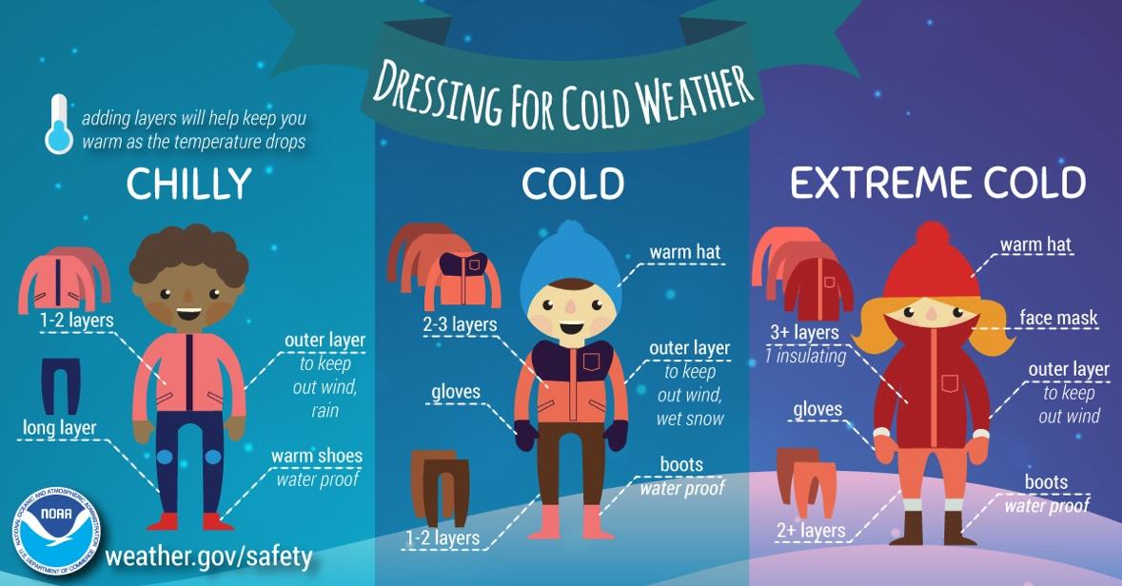 | Checklist for Success:  - Backpack for all gear  - Warm, waterproof, sturdy footwear  - Hat, gloves/mittens, and hand warmers  - Scarf or neck warmer  - Windproof/waterproof/water resistant outer layer  - 1-3 base layers  - Long pants  - Sunscreen or other sun protection  - Lunch  - Water bottle

