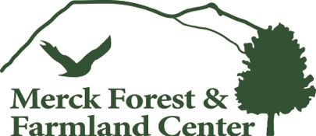
Checklist for Success:
- Backpack for all gear
- Warm, waterproof, sturdy footwear
- Hat, gloves/mittens, and hand warmers
- Scarf or neck warmer
- Windproof/waterproof/water resistant outer layer
- 1-3 base layers
- Long pants
- Sunscreen or other sun protection
- Lunch
- Water bottle

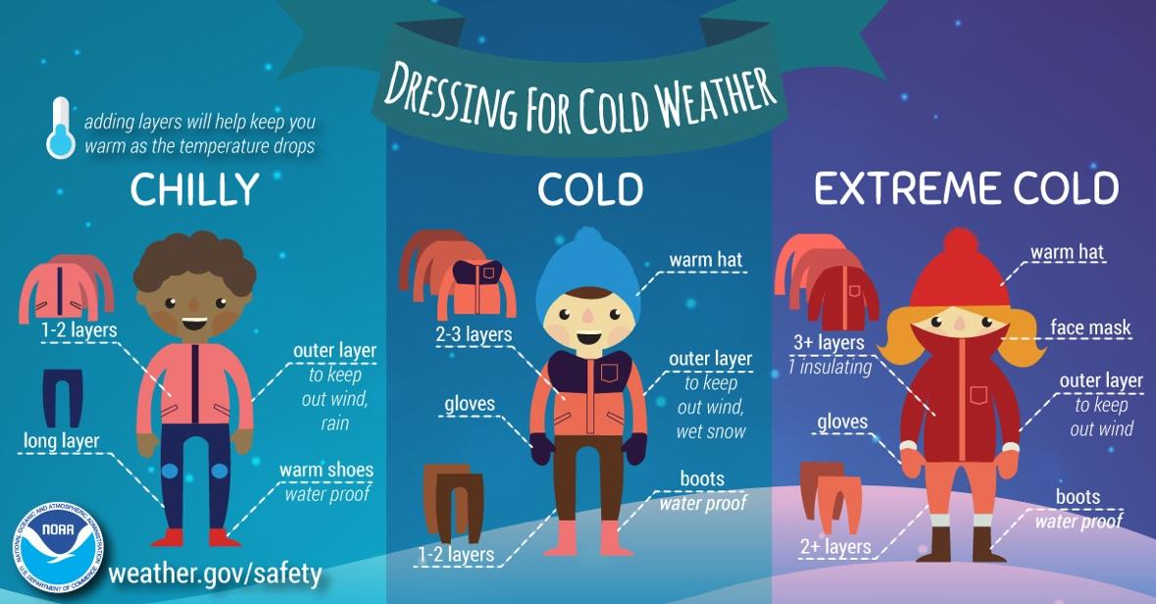

Please remember:

- There are no trash facilities at Merck Forest; we are a carry-in, carry-out facility. If the group will be having lunch at Merck Forest, please note that everyone must carry out their own garbage. Please equip your child with a garbage bag to carry trash out.
- If your child's lunch is packed in a paper bag, please provide them with a waterproof bag to put lunches in if you will be out in the field at lunchtime. Plastic grocery bags work great for this.
- Groups usually elect to have lunch at or near the Sap House, a 1/4 mile walk from the Visitor Center. Please keep this in mind as lunches will need to be carried to the Sap House.

